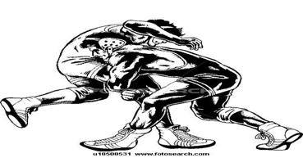

2023
LITTLE, MIDDLE AND HIGH SCHOOL
SUMMER WRESTLING CAMP
SIGN UP CUT OFF DATE-5/22/2023

WEEK1- K-4TH WRESTLERS M-TH 6/5-6/8
TIMES: 6PM-8PM

WEEK2- 5TH-12TH WRESTLERS M-TH 6/12-6/15
TIMES: 6PM-8PM

ADDRESS: 775 Rathmell Rd. Obetz OH 43207
COST-$45
Email this form to coach Jon at wrestlinglando@yahoo.com

Name__________________________________________Age________

Shirt Size________ Emergency Contact#_______________________________

CIRCLE ONE
Attending week- 1 2

WAYS TO PAY:
ZELLE AT- 614-804-8992
VENMO AT-@Jon-Johnson-35
*PLEASE CONFIRM WHEN YOU MAKE THE PAYMENT
*PAYMENT DUE BY 5/22/2023

